A246-Afr-Egy-Ushabti, Ptolemaic Period, 300-350 BCE-Hieroglyphics-Blue Faïence

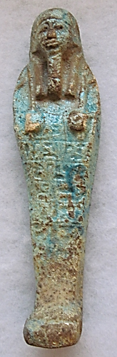 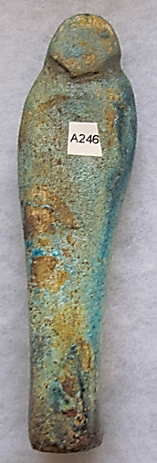

**Formal Label:** Ushabti, Ptolemaic Period, 300-350 BCE-Hieroglyphs-Blue Faïence

**Accession Number: A246**

**Display Description:** Ushabti with hands opposed and sleeved, grasping two hoes as is common for later period Ushabtis. Finely glazed surface. This Ushabti wears a plain lappet wig. Its beard is plaited. It stands on a trapezoidal base. A hieroglyphic inscription down the front has five registers. These anthropomorphic figurines represent servants of the deceased in the Hereafter and were placed with them in their internments. The Amduat [underworld] included tracts of land that were mythically granted to the deceased by the Sun God, Re / Ra, which the Ushabtis were charged with managing. Many tomb frescoes show servants planting fields or fishing in the reeds along the Nile, and these same servants are the ones depicted as Ushabtis. Nobles and royalty were interred with as many of these Ushabti figurines that they felt were necessary so that they would not have to do any manual labor in the Hereafter. Thus, increasingly throughout the Ptolemaic Period, there were proliferations of Ushabtis in grave sites, as patrons sought to out-do their neighbors. This may explain why this Ushabti’s hieroglyphs are somewhat garbled from the *Book of the Dead*, for by this late time its hieroglyphs were not well-understood.

**LC Classification:** DT62

**Date or Time Horizon:** 350-300 BCE

**Geographical Area: Valley of the Kings,** Luxor, Upper Egypt

**Map, GPS Coordinates**: 25.74017 32.60141; 25º44'24.6" N 32º36'5.08" E

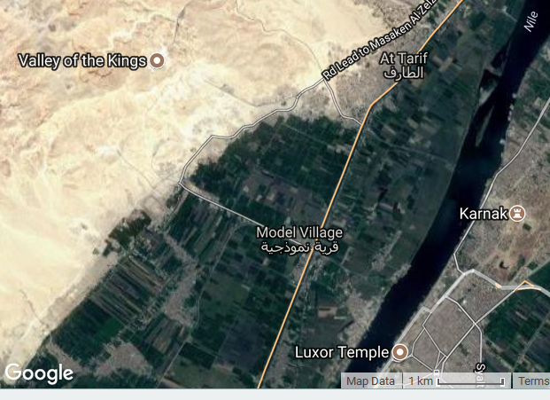

**Cultural Affiliation:** Ptolemaic Period

**Medium:** Faïence

**Dimensions: 153.90 mm; 6.06 in  
Weight: 122 gm; 4.25 oz.**

**Provenance: Ex European collection**

**Condition:** Original

**Discussion:**

Early versions of Ushabtis were modelled to represent the task that the servant would perform and the Ushabtis were portrayed with the tools with which to complete their specific tasks. By the Ptolemaic Period Ushabtis has become a token gesture, and therefore they were almost exclusively mummiform as in this current example, without a specific purpose or job to perform--just a show to the underworld as to the riches of the deceased and his tokens of preventing him from any manual labor.Furthermore, by the Ptolemaic Period (350-300 BCE) there was a wide variation in the meaning and accuracy of hieroglyphs on Ushabtis, since the complex ritual and language of the cult of Osiris had begun to lose popularity.

**References:**

Aubert, J.-F. et L. Aubert. 1974. *Statuettes Egyptiennes: Chaouabtis, Ouchebtis*. Paris, 1974.

Janes, Glenn. 2002. Shabtis. *A Private View, Ancient Egyptian Funerary Statuettes in European Private Collections*. Paris: Cybèle.

Newberry, Percy E. 1930-1957*. Funerary Statuettes and Model Sarcopha*gi.  Le Caire: Impr. de l'Institut français d'archéologie orientale.

Schneider, Hans D. 1977. *Shabtis - An Introduction to the History of Ancient Egyptian Funerary Statuettes. With a Catalogue of the Collection of Shabtis in the National Museum of Leiden*. 3 volumes. Leiden: Rijksmuseum van Oudheden Te Leiden.

Schlögl, Hermann and Andreas Brodbeck. 1990. Ägyptische Totenfiguren aus öffentlichen und privaten Sammlungen der Schweiz. Orbis Biblicus et Orientalis, Series Archeologica, 7. Göttingen, Vandenhoeck & Ruprecht; Freiburg Schweiz, Universitätsverlag.